Trash Bandicoot

The butcher / The gritcher

Porknite

Bark Souls III

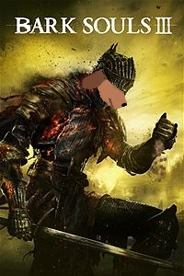

🡨 CROCCHETTE PER CANI